Design and Analysis of Algorithm
Assignment - 1
Complexity comparison table for all Dynamic Programming algorithms.

Name – Hemant Mukhiya
Course – BCA sp. (A.I. and D.S) Sem-5, Sec-A
Roll. No. – 2401201013

Aim:
Measure execution time, space usage, and number of subproblems solved. Prepare a complexity comparison table for all Dynamic Programming algorithms.

1. Theoretical complexity comparison
Parameter | LCS | 0/1 Knapsack | MCM
Input size | m, n | n items, capacity W | n matrices
Number of subproblems | (m+1)(n+1) | (n+1)(W+1) | n(n+1)/2
Time complexity | O(m × n) | O(n × W) | O(n³)
Space complexity | O(m × n) | O(n × W) | O(n²)
Approach | 2D DP table | 2D DP table | 2D DP table
Main objective | Find longest common sequence | Maximize total value | Minimize multiplication cost

Explanation:
- LCS: Solves a subproblem for every pair of character positions in two strings.
- 0/1 Knapsack: Solves a subproblem for each item and each possible capacity.
- MCM: Solves subproblems for matrix-chain intervals and considers possible split positions to find the minimum cost.

2. Measuring execution time, space usage, and subproblems
Python code:
def measure_execution_time(function, *args, repeats=3):
measurements = []
for _ in range(repeats):
start = time.perf_counter()
function(*args)
measurements.append(time.perf_counter() - start)
return min(measurements)

# LCS: increase the length of both strings
lcs_sizes = [20, 40, 60, 80, 100, 120]
lcs_times = []
for size in lcs_sizes:
a = ("ABCDEF" * ((size // 6) + 1))[:size]
b = ("FEDCBA" * ((size // 6) + 1))[:size]
lcs_times.append(measure_execution_time(lcs_algorithm, a, b))

# Knapsack: increase item count and capacity
knapsack_sizes = [5, 10, 15, 20, 25, 30]
knapsack_times = []
for count in knapsack_sizes:
w = [((i * 3) % 9) + 1 for i in range(count)]
v = [((i * 7) % 20) + 5 for i in range(count)]
cap = count * 5
knapsack_times.append(
measure_execution_time(knapsack_algorithm, w, v, cap)
)

# MCM: increase number of matrices
mcm_sizes = [3, 5, 7, 9, 11, 13]
mcm_times = []
for count in mcm_sizes:
dims = [((i * 7) % 25) + 5 for i in range(count + 1)]
mcm_times.append(measure_execution_time(matrix_chain_algorithm, dims))

fig, axes = plt.subplots(1, 3, figsize=(17, 4))

axes[0].plot(lcs_sizes, lcs_times, marker="o")
axes[0].set_title("LCS Performance")
axes[0].set_xlabel("Length of each string")
axes[0].set_ylabel("Execution time (seconds)")

axes[1].plot(knapsack_sizes, knapsack_times, marker="o")
axes[1].set_title("0/1 Knapsack Performance")
axes[1].set_xlabel("Number of items (capacity increases too)")
axes[1].set_ylabel("Execution time (seconds)")

axes[2].plot(mcm_sizes, mcm_times, marker="o")
axes[2].set_title("MCM Performance")
axes[2].set_xlabel("Number of matrices")
axes[2].set_ylabel("Execution time (seconds)")

plt.tight_layout()
plt.show()

performance_report = pd.DataFrame({
"Algorithm": ["LCS", "0/1 Knapsack", "Matrix Chain Multiplication"],
"Input sizes": [str(lcs_sizes), str(knapsack_sizes), str(mcm_sizes)],
"Execution times (seconds)": [
[round(x, 6) for x in lcs_times],
[round(x, 6) for x in knapsack_times],
[round(x, 6) for x in mcm_times]
],
"Theoretical time complexity": ["O(m × n)", "O(n × W)", "O(n³)"]
})

print("Performance Report")
display(performance_report)

memory_records = []

# LCS DP array memory
a = "ABCDEF" * 20
b = "FEDCBA" * 20
dp, result = lcs_algorithm(a, b)
memory_records.append(("LCS", dp.nbytes / 1024))

# Knapsack DP array memory
w = [2, 3, 4, 5, 6, 7, 8, 9]
v = [5, 7, 8, 9, 10, 12, 13, 15]
dp, best, selected = knapsack_algorithm(w, v, 30)
memory_records.append(("0/1 Knapsack", dp.nbytes / 1024))

# MCM DP and split arrays
dims = [10, 20, 30, 15, 25, 10, 5]
dp, split, best, order = matrix_chain_algorithm(dims)
memory_records.append(("Matrix Chain Multiplication",
(dp.nbytes + split.nbytes) / 1024))

memory_report = pd.DataFrame(
memory_records,
columns=["Algorithm", "DP array memory (KB)"]
)

display(memory_report)

plt.figure(figsize=(8, 4))
plt.bar(memory_report["Algorithm"], memory_report["DP array memory (KB)"])
plt.title("Memory Used by DP Arrays")
plt.ylabel("Memory (KB)")
plt.xticks(rotation=15)
plt.tight_layout()
plt.show()

Output :-
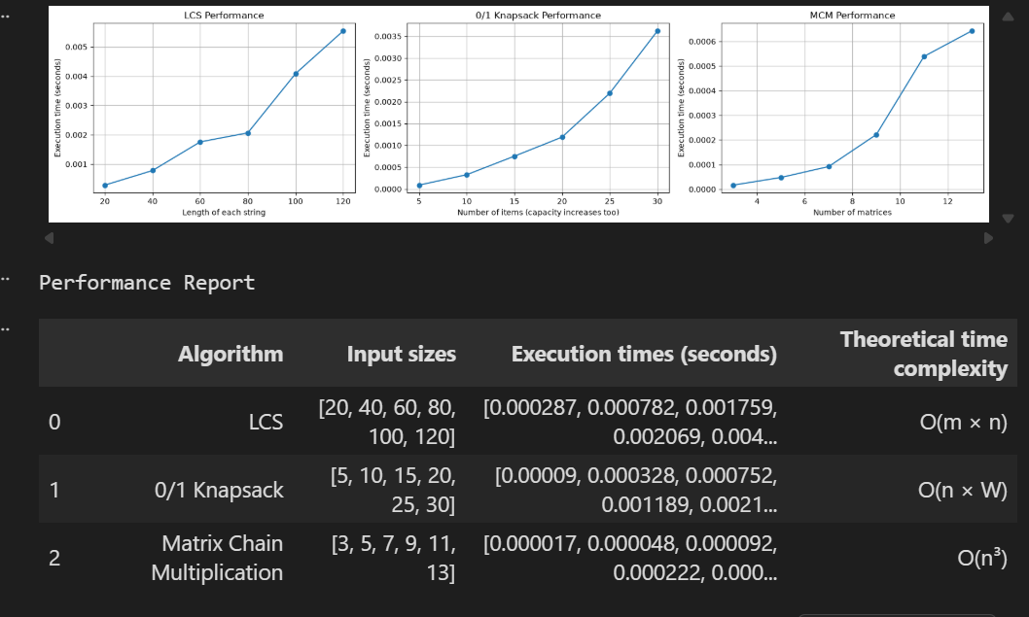

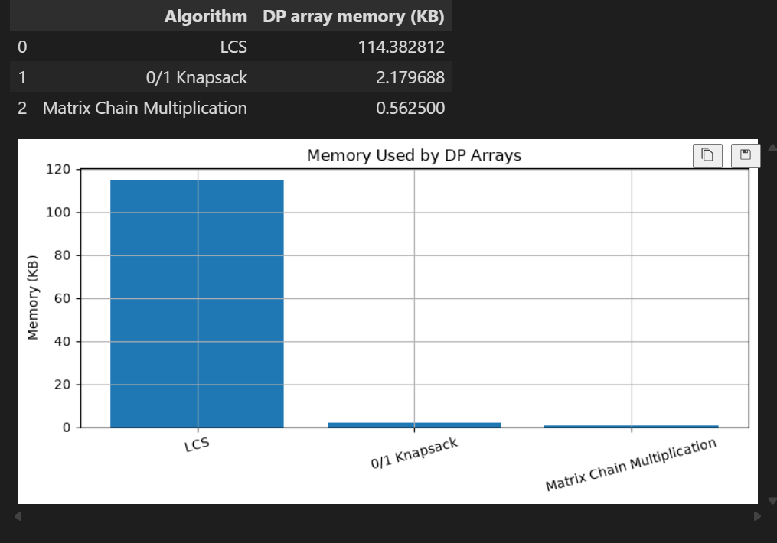

3. Conclusion (for your 5-mark report)
Dynamic Programming provides an efficient approach to solving optimization problems by dividing them into smaller subproblems and storing their results.
- LCS requires O(m × n) time and space to find the longest common subsequence.
- 0/1 Knapsack requires O(n × W) time and space to maximize the total value within a given capacity.
- Matrix Chain Multiplication requires O(n³) time and O(n²) space to determine the optimal multiplication order.
The experimental comparison shows how execution time and memory requirements change according to input size and the number of subproblems. These measurements help evaluate the efficiency and scalability of the implemented algorithms.

Github - github

